***………………………………………………………***

***……………………………………………….***

***A Project on***

STUDENT REPORT CARD SYSTEM

***……………………….***

***…………………………………….***

***Content***

***1. Introduction***

***2. Source Code***

***3. Output***

***4. Requirement***

***5. Advantages and disadvantages***

***6. Conclusion***



This project ***STUDENT REPORT CARD SYSTEM*** includes facilities of registration, search, display, modification, deletion of student information about the marks and their name and rolls number. This software searches the student information on the basis of roll number which is store in the record.

The software used for small schools for maintaining their records related to report card and marks of student and cost savings.



//***************************************************************

* HEADER FILE USED IN PROJECT //**************************************************************** #include<iostream.h>

#include<fstream.h>

#include<iomanip.h>

#include<stdio.h>

#include<conio.h>

#include<stdlib.h>

#include<string.h>

#include<ctype.h> void entry_menu(); int checkpass(); int selectgroup(); void intromain(); void intro();

void display_all(); void display_allrec(); int getrollno();

void modify_record(int n); void delete_record(int n); void againopenandclose(); void reportcard(int c); //***************************************************************

* CLASS USED IN PROJECT //****************************************************************

class student

{ int group;

int rollno;

char name[50];

int p_marks,c_marks,m_marks,e_marks,cs_marks,b_marks,phyed_marks; int eco_marks,bstud_marks,account_marks,total;

float per;

char grade;

void calculate(int c);

//function to calculate grade

public:

student()

{

rollno=0;group=0;p_marks=0;c_marks=0;m_marks=0;e_marks=0;

cs_marks=0;b_marks=0;eco_marks=0;phyed_marks=0;bstud_marks=0; account_marks=0;total=0;per=0.00;

}

void getdatamulti(int c,int rn1);

void showdatamulti();

void showall(int c);

void reportcard();

void modifydata(int n1,char snm[15],int grp);

int retrollno()

{ return rollno; }

char *getnm()

{ return name; }

int getgroup()

{ return group; }

}; //class ends here

//*****************************************************

* report card of the student //**************************************************** void student::reportcard()

{

clrscr();

gotoxy(1,2);

cout<<"**************************DOON PUBLIC SCHOOOL,HALDWANI**************************"; gotoxy(1,3);

cout<<"********************************************************************************";

gotoxy(24,4); cout<<"-------------REPORT CARD-------------";

gotoxy(1,5);

cout<<"================================================================================";

gotoxy(5,6); cout<<"ROLL NO:";

gotoxy(18,6); cout<<rollno;

gotoxy(40,6); cout<<"NAME OF STUDENT:";

gotoxy(60,6); cout<<name;

gotoxy(1,7);

cout<<"================================================================================";

gotoxy(12,8); cout<<"------------------------------------------------------------|";

gotoxy(11,8); cout<<"|";

gotoxy(15,9); cout<<"S.NO";

gotoxy(25,8); cout<<"|";

gotoxy(30,9); cout<<"SUBJECTS";

gotoxy(48,8); cout<<"|";

gotoxy(55,9); cout<<"MARKS";

gotoxy(65,8); cout<<"|";

gotoxy(12,10);cout<<"------------------------------------------------------------|";

gotoxy(11,10);cout<<"|";

gotoxy(25,10);cout<<"|";

gotoxy(48,10);cout<<"|";

gotoxy(65,10);cout<<"|";

//**********************subjects with marks column wise******************* switch(group)

{

case 1:

gotoxy(11,11);cout<<"|";

gotoxy(15,11);cout<<"1.";

gotoxy(25,11);cout<<"|";

gotoxy(30,11);cout<<"ENGLISH";

gotoxy(48,11);cout<<"|";

gotoxy(55,11);cout<<e_marks;

gotoxy(65,11);cout<<"|";

gotoxy(72,11);cout<<"|";

//**************second subject

gotoxy(11,12);cout<<"|";

gotoxy(15,12);cout<<"2.";

gotoxy(25,12);cout<<"|";

gotoxy(30,12);cout<<"PHYSICS";

gotoxy(48,12);cout<<"|";

gotoxy(55,12);cout<<p_marks;

gotoxy(65,12);cout<<"|";

gotoxy(72,12);cout<<"|";

//*****************************************

//**************third subject

gotoxy(11,13);cout<<"|";

gotoxy(15,13);cout<<"3.";

gotoxy(25,13);cout<<"|";

gotoxy(30,13);cout<<"CHEMISTRY";

gotoxy(48,13);cout<<"|";

gotoxy(55,13);cout<<c_marks;

gotoxy(65,13);cout<<"|";

gotoxy(72,13);cout<<"|";

//**************third subject

gotoxy(11,14);cout<<"|";

gotoxy(15,14);cout<<"4.";

gotoxy(25,14);cout<<"|";

gotoxy(30,14);cout<<"MATHS";

gotoxy(48,14);cout<<"|";

gotoxy(55,14);cout<<m_marks;

gotoxy(65,14);cout<<"|";

gotoxy(72,14);cout<<"|";

//**************third subject

gotoxy(11,15);cout<<"|";

gotoxy(15,15);cout<<"5.";

gotoxy(25,15);cout<<"|";

gotoxy(30,15);cout<<"PHYSICAL EDUCATION";

gotoxy(48,15);cout<<"|";

gotoxy(55,15);cout<<phyed_marks;

gotoxy(65,15);cout<<"|";

gotoxy(72,15);cout<<"|";

break;

case 2:

//**********************first subject*****************

gotoxy(11,11);cout<<"|";

gotoxy(15,11);cout<<"1.";

gotoxy(25,11);cout<<"|";

gotoxy(30,11);cout<<"ENGLISH:";

gotoxy(48,11);cout<<"|";

gotoxy(55,11);cout<<e_marks;

gotoxy(65,11);cout<<"|";

gotoxy(72,11);cout<<"|";

//**************second subject

gotoxy(11,12);cout<<"|";

gotoxy(15,12);cout<<"2.";

gotoxy(25,12);cout<<"|";

gotoxy(30,12);cout<<"PHYSICS:";

gotoxy(48,12);cout<<"|";

gotoxy(55,12);cout<<p_marks;

gotoxy(65,12);cout<<"|";

gotoxy(72,12);cout<<"|";

//*****************************************

//**************third subject

gotoxy(11,13);cout<<"|";

gotoxy(15,13);cout<<"3.";

gotoxy(25,13);cout<<"|";

gotoxy(30,13);cout<<"CHEMISTRY:";

gotoxy(48,13);cout<<"|";

gotoxy(55,13);cout<<c_marks;

gotoxy(65,13);cout<<"|";

gotoxy(72,13);cout<<"|";

//**************fourth subject

gotoxy(11,14);cout<<"|";

gotoxy(15,14);cout<<"4.";

gotoxy(25,14);cout<<"|";

gotoxy(30,14);cout<<"MATHS:";

gotoxy(48,14);cout<<"|";

gotoxy(55,14);cout<<m_marks;

gotoxy(65,14);cout<<"|";

gotoxy(72,14);cout<<"|";

//**************fifth subject

gotoxy(11,15);cout<<"|";

gotoxy(15,15);cout<<"5.";

gotoxy(25,15);cout<<"|";

gotoxy(30,15);cout<<"COMPUTER SCIENCE:";

gotoxy(48,15);cout<<"|";

gotoxy(55,15);cout<<cs_marks;

gotoxy(65,15);cout<<"|";

gotoxy(72,15);cout<<"|";

break;

case 3:

//**********************first subject*****************

gotoxy(11,11);cout<<"|";

gotoxy(15,11);cout<<"1.";

gotoxy(25,11);cout<<"|";

gotoxy(30,11);cout<<"ENGLISH:";

gotoxy(48,11);cout<<"|";

gotoxy(55,11);cout<<e_marks;

gotoxy(65,11);cout<<"|";

gotoxy(72,11);cout<<"|";

//**************second subject

gotoxy(11,12);cout<<"|";

gotoxy(15,12);cout<<"2.";

gotoxy(25,12);cout<<"|";

gotoxy(30,12);cout<<"PHYSICS:";

gotoxy(48,12);cout<<"|";

gotoxy(55,12);cout<<p_marks;

gotoxy(65,12);cout<<"|";

gotoxy(72,12);cout<<"|";

//*****************************************

//**************third subject

gotoxy(11,13);cout<<"|";

gotoxy(15,13);cout<<"3.";

gotoxy(25,13);cout<<"|";

gotoxy(30,13);cout<<"CHEMISTRY:";

gotoxy(48,13);cout<<"|";

gotoxy(55,13);cout<<c_marks;

gotoxy(65,13);cout<<"|";

gotoxy(72,13);cout<<"|";

//**************fourth subject

gotoxy(11,14);cout<<"|";

gotoxy(15,14);cout<<"4.";

gotoxy(25,14);cout<<"|";

gotoxy(30,14);cout<<"MATHS:";

gotoxy(48,14);cout<<"|";

gotoxy(55,14);cout<<m_marks;

gotoxy(65,14);cout<<"|";

gotoxy(72,14);cout<<"|";

//**************fifth subject

gotoxy(11,15);cout<<"|";

gotoxy(15,15);cout<<"5.";

gotoxy(25,15);cout<<"|";

gotoxy(30,15);cout<<"BIOLOGY:";

gotoxy(48,15);cout<<"|";

gotoxy(55,15);cout<<b_marks;

gotoxy(65,15);cout<<"|";

gotoxy(72,15);cout<<"|";

break;

case 4:

//**********************first subject*****************

gotoxy(11,11);cout<<"|";

gotoxy(15,11);cout<<"1.";

gotoxy(25,11);cout<<"|";

gotoxy(30,11);cout<<"ENGLISH:";

gotoxy(48,11);cout<<"|";

gotoxy(55,11);cout<<e_marks;

gotoxy(65,11);cout<<"|";

gotoxy(72,11);cout<<"|";

//**************second subject

gotoxy(11,12);cout<<"|";

gotoxy(15,12);cout<<"2.";

gotoxy(25,12);cout<<"|";

gotoxy(30,12);cout<<"PHYSICS:";

gotoxy(48,12);cout<<"|";

gotoxy(55,12);cout<<p_marks;

gotoxy(65,12);cout<<"|";

gotoxy(72,12);cout<<"|";

//*****************************************

//**************third subject

gotoxy(11,13);cout<<"|";

gotoxy(15,13);cout<<"3.";

gotoxy(25,13);cout<<"|";

gotoxy(30,13);cout<<"CHEMISTRY:";

gotoxy(48,13);cout<<"|";

gotoxy(55,13);cout<<c_marks;

gotoxy(65,13);cout<<"|";

gotoxy(72,13);cout<<"|";

//**************fourth subject

gotoxy(11,14);cout<<"|";

gotoxy(15,14);cout<<"4.";

gotoxy(25,14);cout<<"|";

gotoxy(30,14);cout<<"BIOLOGY:";

gotoxy(48,14);cout<<"|";

gotoxy(55,14);cout<<b_marks;

gotoxy(65,14);cout<<"|";

gotoxy(72,14);cout<<"|";

//**************fifth subject

gotoxy(11,15);cout<<"|";

gotoxy(15,15);cout<<"5.";

gotoxy(25,15);cout<<"|";

gotoxy(30,15);cout<<"PHYSICAL EDUCATION";

gotoxy(48,15);cout<<"|";

gotoxy(55,15);cout<<phyed_marks;

gotoxy(65,15);cout<<"|";

gotoxy(72,15);cout<<"|";

break;

case 5:

//**********************first subject*****************

gotoxy(11,11);cout<<"|";

gotoxy(15,11);cout<<"1.";

gotoxy(25,11);cout<<"|";

gotoxy(30,11);cout<<"ENGLISH:";

gotoxy(48,11);cout<<"|";

gotoxy(55,11);cout<<e_marks;

gotoxy(65,11);cout<<"|";

gotoxy(72,11);cout<<"|";

//**************second subject

gotoxy(11,12);cout<<"|";

gotoxy(15,12);cout<<"2.";

gotoxy(25,12);cout<<"|";

gotoxy(30,12);cout<<"PHYSICS:";

gotoxy(48,12);cout<<"|";

gotoxy(55,12);cout<<p_marks;

gotoxy(65,12);cout<<"|";

gotoxy(72,12);cout<<"|";

//*****************************************

//**************third subject

gotoxy(11,13);cout<<"|";

gotoxy(15,13);cout<<"3.";

gotoxy(25,13);cout<<"|";

gotoxy(30,13);cout<<"CHEMISTRY:";

gotoxy(48,13);cout<<"|";

gotoxy(55,13);cout<<c_marks;

gotoxy(65,13);cout<<"|";

gotoxy(72,13);cout<<"|";

//**************fourth subject

gotoxy(11,14);cout<<"|";

gotoxy(15,14);cout<<"4.";

gotoxy(25,14);cout<<"|";

gotoxy(30,14);cout<<"BIOLOGY:";

gotoxy(48,14);cout<<"|";

gotoxy(55,14);cout<<b_marks;

gotoxy(65,14);cout<<"|";

gotoxy(72,14);cout<<"|";

//**************fifth subject

gotoxy(11,15);cout<<"|";

gotoxy(15,15);cout<<"5.";

gotoxy(25,15);cout<<"|";

gotoxy(30,15);cout<<"COMPUTER SCIENCE";

gotoxy(48,15);cout<<"|";

gotoxy(55,15);cout<<cs_marks;

gotoxy(65,15);cout<<"|";

gotoxy(72,15);cout<<"|";

break;

case 6:

//**********************first subject*****************

gotoxy(11,11);cout<<"|";

gotoxy(15,11);cout<<"1.";

gotoxy(25,11);cout<<"|";

gotoxy(30,11);cout<<"ENGLISH:";

gotoxy(48,11);cout<<"|";

gotoxy(55,11);cout<<e_marks;

gotoxy(65,11);cout<<"|";

gotoxy(72,11);cout<<"|";

//**************second subject

gotoxy(11,12);cout<<"|";

gotoxy(15,12);cout<<"2.";

gotoxy(25,12);cout<<"|";

gotoxy(30,12);cout<<"ACCOUNTS:";

gotoxy(48,12);cout<<"|";

gotoxy(55,12);cout<<account_marks;

gotoxy(65,12);cout<<"|";

gotoxy(72,12);cout<<"|";

//*****************************************

//**************third subject

gotoxy(11,13);cout<<"|";

gotoxy(15,13);cout<<"3.";

gotoxy(25,13);cout<<"|";

gotoxy(30,13);cout<<"BUSINESS STUDIES:";

gotoxy(48,13);cout<<"|";

gotoxy(55,13);cout<<bstud_marks;

gotoxy(65,13);cout<<"|";

gotoxy(72,13);cout<<"|";

//**************fourth subject

gotoxy(11,14);cout<<"|";

gotoxy(15,14);cout<<"4.";

gotoxy(25,14);cout<<"|";

gotoxy(30,14);cout<<"ECONOMICS:";

gotoxy(48,14);cout<<"|";

gotoxy(55,14);cout<<eco_marks;

gotoxy(65,14);cout<<"|";

gotoxy(72,14);cout<<"|";

//**************fifth subject

gotoxy(11,15);cout<<"|";

gotoxy(15,15);cout<<"5.";

gotoxy(25,15);cout<<"|";

gotoxy(30,15);cout<<"PHYSICAL EDUCATION";

gotoxy(48,15);cout<<"|";

gotoxy(55,15);cout<<phyed_marks;

gotoxy(65,15);cout<<"|";

gotoxy(72,15);cout<<"|";

break;

case 7:

//**********************first subject*****************

gotoxy(11,11);cout<<"|";

gotoxy(15,11);cout<<"1.";

gotoxy(25,11);cout<<"|";

gotoxy(30,11);cout<<"ENGLISH:";

gotoxy(48,11);cout<<"|";

gotoxy(55,11);cout<<e_marks;

gotoxy(65,11);cout<<"|";

gotoxy(72,11);cout<<"|";

//**************second subject

gotoxy(11,12);cout<<"|";

gotoxy(15,12);cout<<"2.";

gotoxy(25,12);cout<<"|";

gotoxy(30,12);cout<<"ACCOUNTS:";

gotoxy(48,12);cout<<"|";

gotoxy(55,12);cout<<account_marks;

gotoxy(65,12);cout<<"|";

gotoxy(72,12);cout<<"|";

//*****************************************

//**************third subject

gotoxy(11,13);cout<<"|";

gotoxy(15,13);cout<<"3.";

gotoxy(25,13);cout<<"|";

gotoxy(30,13);cout<<"BUSINESS STUDIES:";

gotoxy(48,13);cout<<"|";

gotoxy(55,13);cout<<bstud_marks;

gotoxy(65,13);cout<<"|";

gotoxy(72,13);cout<<"|";

//**************fourth subject

gotoxy(11,14);cout<<"|";

gotoxy(15,14);cout<<"4.";

gotoxy(25,14);cout<<"|";

gotoxy(30,14);cout<<"ECONOMICS:";

gotoxy(48,14);cout<<"|";

gotoxy(55,14);cout<<eco_marks;

gotoxy(65,14);cout<<"|";

gotoxy(72,14);cout<<"|";

//**************fifth subject

gotoxy(11,15);cout<<"|";

gotoxy(15,15);cout<<"5.";

gotoxy(25,15);cout<<"|";

gotoxy(30,15);cout<<"COMPUTER SCIENCE";

gotoxy(48,15);cout<<"|";

gotoxy(55,15);cout<<cs_marks;

gotoxy(65,15);cout<<"|";

gotoxy(72,15);cout<<"|";

break;

}

gotoxy(12,16);cout<<"------------------------------------------------------------|";

gotoxy(11,16);cout<<"|";

gotoxy(25,16);cout<<"|";

gotoxy(48,16);cout<<"|";

gotoxy(65,16);cout<<"|";

//*******************total per and grade of the student****************

gotoxy(8,18); cout<<"TOTAL:";

gotoxy(17,18);cout<<total;

gotoxy(45,18);cout<<"PERCENTAGE:";

gotoxy(60,18);cout<<per;

gotoxy(8,20);cout<<"MARKS IN WORDS:";

gotoxy(25,20);cout<<"THIRTY HUNDRED FOURTY";

gotoxy(24,22);cout<<"-----------DIVISION:";

gotoxy(48,22);

switch(grade)

{

case 'A': cout<<"FIRST";

break;

case 'B': cout<<"SECOND";

break;

case 'C': cout<<"THIRD";

break;

case 'D': cout<<"FAIL";

break;

}

cout<<"-----------------";

}

//************report card ends here******************

//*****************************************************8

// modify the records of the student

//*****************************************************

void student::modifydata(int n1,char snm[15],int grp)

{

char tmpnm[50]="blank";

gotoxy(5,17);

cout<<"===================WANT TO MODIFY NAME==============================="; gotoxy(10,18); cout<<"Roll No:";

rollno=n1; gotoxy(18,18);

cout<<rollno; gotoxy(28,18);

strcpy(name,snm); cout<<"NAME OF STUDENT:";

gotoxy(50,18); cout<<name;

gotoxy(10,19); cout<<"Want to change the name";

gotoxy(40,19); int flag=0;

while(1)

{

gets(tmpnm);

if(strlen(tmpnm)!=0)

{

flag=1;

break;

}

if(strlen(tmpnm)==0)

{ flag=0; break;

}

}

if(flag==1)

{ strcpy(name,tmpnm);

}

gotoxy(5,21);

cout<<"=====================================================================";

switch(grp)

{

case 1: group=1;gotoxy(1,22);

cout<<"********MODIFY**MARKS OF FIVE SUBJECTS[PCM WITH PHY EDU.]*********************";

gotoxy(1,23); cout<<"ENGLISH:"; gotoxy(15,23);cin>>e_marks; gotoxy(30,23);cout<<"PHYSICS:"; gotoxy(45,23);cin>>p_marks; gotoxy(50,23);cout<<"CHEMISTRY:"; gotoxy(61,23);cin>>c_marks; gotoxy(1,24);cout<<"MATHS:"; gotoxy(15,24);cin>>m_marks; gotoxy(35,24);cout<<"PHYSICAL EDUCATION:"; gotoxy(58,24);cin>>phyed_marks; calculate(1);

break;

case 2: group=2;gotoxy(1,22);

cout<<"*********MODIFY**MARKS OF FIVE SUBJECTS[PCM WITH COMP.SC.]*******************";

gotoxy(1,23); cout<<"ENGLISH:"; gotoxy(15,23);cin>>e_marks; gotoxy(30,23);cout<<"PHYSICS:"; gotoxy(45,23);cin>>p_marks; gotoxy(50,23);cout<<"CHEMISTRY:"; gotoxy(61,23);cin>>c_marks; gotoxy(1,24);cout<<"MATHS:"; gotoxy(15,24);cin>>m_marks; gotoxy(35,24);cout<<"COMPUTER SCIENCE:"; gotoxy(58,24);cin>>cs_marks;

calculate(2);

break; case 3: group=3;gotoxy(1,22);

cout<<"*******MODIFY**MARKS OF FIVE SUBJECTS[PCM WITH BIO.]*******************"; gotoxy(1,23);cout<<"ENGLISH:";

gotoxy(15,23);cin>>e_marks; gotoxy(30,23);cout<<"PHYSICS:"; gotoxy(45,23);cin>>p_marks; gotoxy(50,23);cout<<"CHEMISTRY:"; gotoxy(61,23);cin>>c_marks; gotoxy(1,24);cout<<"MATHS:"; gotoxy(15,24);cin>>m_marks; gotoxy(35,24);cout<<"BIOLOGY:"; gotoxy(58,24);cin>>b_marks; calculate(3);

break; case 4: group=4;gotoxy(1,22);

cout<<"*******MODIFY**MARKS OF FIVE SUBJECTS[PCB WITH PHY.ED.]*******************"; gotoxy(1,23);cout<<"ENGLISH:";

gotoxy(15,23);cin>>e_marks;

gotoxy(30,23);cout<<"PHYSICS:";

gotoxy(45,23);cin>>p_marks;

gotoxy(50,23);cout<<"CHEMISTRY:";

gotoxy(61,23);cin>>c_marks;

gotoxy(1,24);cout<<"BIOLOGY::";

gotoxy(15,24);cin>>b_marks;

gotoxy(35,24);cout<<"PHYSICAL EDUCATION";

gotoxy(58,24);cin>>phyed_marks;

calculate(4);

break;

case 5:group=5;gotoxy(1,22);

cout<<"*******MODIFY***MARKS OF FIVE SUBJECTS[PCB WITH COMP.SCI.]*******************";

gotoxy(1,23); cout<<"ENGLISH:";

gotoxy(15,23);cin>>e_marks;

gotoxy(30,23);cout<<"PHYSICS:";

gotoxy(45,23);cin>>p_marks;

gotoxy(50,23);cout<<"CHEMISTRY:";

gotoxy(61,23);cin>>c_marks;

gotoxy(1,24); cout<<"BIOLOGY::";

gotoxy(15,24);cin>>b_marks;

gotoxy(35,24);cout<<"COMPUTER SCIENCE";

gotoxy(58,24);cin>>cs_marks;

calculate(5);

break;

case 6:

group=6;gotoxy(1,22);

cout<<"********MODIFY**MARKS OF FIVE SUBJECTS[COMMERCE WITH PHY.ED.]*****************"; gotoxy(1,23);cout<<"ENGLISH:";

gotoxy(15,23);cin>>e_marks;

gotoxy(30,23);cout<<"ACCOUNTS:";

gotoxy(45,23);cin>>account_marks;

gotoxy(50,23);cout<<"BUSINESS STUDIES:";

gotoxy(70,23);cin>>bstud_marks;

gotoxy(1,24);cout<<"ECONOMICS:";

gotoxy(15,24);cin>>eco_marks;

gotoxy(35,24);cout<<"PHYSICAL EDUCATION";

gotoxy(58,24);cin>>phyed_marks;

calculate(6);

break;

case 7: group=7;gotoxy(1,22);

cout<<"*****MODIFY***MARKS OF FIVE SUBJECTS[COMMERCE WITH COMP.SCI.]**************"; gotoxy(1,23);cout<<"ENGLISH:";

gotoxy(15,23);cin>>e_marks;

gotoxy(30,23);cout<<"ACCOUNTS:";

gotoxy(45,23);cin>>account_marks;

gotoxy(50,23);cout<<"BUSINESS STUDIES:";

gotoxy(70,23);cin>>bstud_marks;

gotoxy(1,24);cout<<"ECONOMICS:";

gotoxy(15,24);cin>>eco_marks;

gotoxy(35,24);cout<<"PHYSICAL EDUCATION";

gotoxy(58,24);cin>>cs_marks;

calculate(7);

break;

}

}

//**********************modification exists************************************ //*****************************************************************************

// save the records of student on the basis of subject choice:

//*****************************************************************************

void student::getdatamulti(int c,int rn1)

{

gotoxy(5,7);

cout<<"======================================================================"; gotoxy(10,8); cout<<"Roll No:";

rollno=rn1; gotoxy(18,8);

cout<<rollno; gotoxy(35,8);

cout<<"NAME OF STUDENT:";

gotoxy(54,8); cin>>name;

gotoxy(5,9); cout<<"====================================================================="; switch(c)

{

case 1:

group=1;gotoxy(1,10);

cout<<"*****************MARKS OF FIVE SUBJECTS[PCM WITH PHY EDU.]*********************"; gotoxy(10,11);cout<<"ENGLISH:";

gotoxy(20,11);cin>>e_marks;

gotoxy(35,11);cout<<"PHYSICS:";

gotoxy(45,11);cin>>p_marks;

gotoxy(10,12);cout<<"CHEMISTRY:";

gotoxy(20,12);cin>>c_marks;

gotoxy(35,12);cout<<"MATHS:";

gotoxy(45,12);cin>>m_marks;

gotoxy(10,13);cout<<"PHYSICAL EDUCATION:";

gotoxy(32,13);cin>>phyed_marks;

calculate(1);

break;

case 2: group=2;gotoxy(1,10);

cout<<"*****************MARKS OF FIVE SUBJECTS[PCM WITH COMP.SC.]*******************"; gotoxy(10,11);cout<<"ENGLISH:";

gotoxy(20,11);cin>>e_marks;

gotoxy(35,11);cout<<"PHYSICS:";

gotoxy(45,11);cin>>p_marks;

gotoxy(10,12);cout<<"CHEMISTRY:";

gotoxy(20,12);cin>>c_marks;

gotoxy(35,12);cout<<"MATHS:";

gotoxy(45,12);cin>>m_marks;

gotoxy(10,13);cout<<"COMPUTER SCIENCE:";

gotoxy(32,13);cin>>cs_marks;

calculate(2);

break;

case 3: group=3;gotoxy(1,10);

cout<<"****************MARKS OF FIVE SUBJECTS[PCM WITH BIO.]*******************"; gotoxy(10,11);cout<<"ENGLISH:";

gotoxy(20,11);cin>>e_marks;

gotoxy(35,11);cout<<"PHYSICS:";

gotoxy(45,11);cin>>p_marks;

gotoxy(10,12);cout<<"CHEMISTRY:";

gotoxy(20,12);cin>>c_marks;

gotoxy(35,12);cout<<"MATHS:";

gotoxy(45,12);cin>>m_marks;

gotoxy(10,13);cout<<"BIOLOGY:";

gotoxy(32,13);cin>>b_marks;

calculate(3);

break;

case 4:

group=4;gotoxy(1,10);

cout<<"****************MARKS OF FIVE SUBJECTS[PCB WITH PHY.ED.]*******************"; gotoxy(10,11);cout<<"ENGLISH:";

gotoxy(20,11);cin>>e_marks;

gotoxy(35,11);cout<<"PHYSICS:";

gotoxy(45,11);cin>>p_marks;

gotoxy(10,12);cout<<"CHEMISTRY:";

gotoxy(20,12);cin>>c_marks;

gotoxy(35,12);cout<<"BIOLOGY::";

gotoxy(45,12);cin>>b_marks;

gotoxy(10,13);cout<<"PHYSICAL EDUCATION";

gotoxy(32,13);cin>>phyed_marks;

calculate(4);

break;

case 5:

group=5;gotoxy(1,10);

cout<<"****************MARKS OF FIVE SUBJECTS[PCB WITH COMP.SCI.]*******************"; gotoxy(10,11);cout<<"ENGLISH:";

gotoxy(20,11);cin>>e_marks;

gotoxy(35,11);cout<<"PHYSICS:";

gotoxy(45,11);cin>>p_marks;

gotoxy(10,12);cout<<"CHEMISTRY:";

gotoxy(20,12);cin>>c_marks;

gotoxy(35,12);cout<<"BIOLOGY::";

gotoxy(45,12);cin>>b_marks;

gotoxy(10,13);cout<<"COMPUTER SCIENCE";

gotoxy(32,13);cin>>cs_marks;

calculate(5);

break;

case 6:

group=6;gotoxy(1,10);

cout<<"****************MARKS OF FIVE SUBJECTS[COMMERCE WITH PHY.ED.]*****************"; gotoxy(10,11);cout<<"ENGLISH:";

gotoxy(20,11);cin>>e_marks;

gotoxy(35,11);cout<<"ACCOUNTS:";

gotoxy(45,11);cin>>account_marks;

gotoxy(10,12);cout<<"BUSINESS STUDIES:";

gotoxy(30,12);cin>>bstud_marks;

gotoxy(38,12);cout<<"ECONOMICS:";

gotoxy(52,12);cin>>eco_marks;

gotoxy(10,13);cout<<"PHYSICAL EDUCATION";

gotoxy(45,13);cin>>phyed_marks;

calculate(6);

break;

case 7:

group=7;gotoxy(1,10);

cout<<"**********MARKS OF FIVE SUBJECTS[COMMERCE WITH COMP.SCI.]****************"; gotoxy(10,11);cout<<"ENGLISH:";

gotoxy(20,11);cin>>e_marks;

gotoxy(35,11);cout<<"ACCOUNTS:";

gotoxy(45,11);cin>>account_marks;

gotoxy(10,12);cout<<"BUSINESS STUDIES:";

gotoxy(32,12);cin>>bstud_marks;

gotoxy(38,12);cout<<"ECONOMICS:";

gotoxy(52,12);cin>>eco_marks;

gotoxy(10,13);cout<<"PHYSICAL EDUCATION";

gotoxy(45,13);cin>>cs_marks;

calculate(7);

break;

}

}

//************************calculate multiple********************************* void student::calculate(int c)

{

switch(c)

{

case 1:

total=p_marks+c_marks+m_marks+e_marks+phyed_marks; per=(p_marks+c_marks+m_marks+e_marks+phyed_marks)/5.0; break;

case 2:

total=p_marks+c_marks+m_marks+e_marks+cs_marks;

per=(p_marks+c_marks+m_marks+e_marks+cs_marks)/5.0;

break;

case 3:

total=p_marks+c_marks+m_marks+e_marks+b_marks;

per=(p_marks+c_marks+m_marks+e_marks+b_marks)/5.0;

break;

case 4:

total=p_marks+c_marks+b_marks+e_marks+phyed_marks; per=(p_marks+c_marks+b_marks+e_marks+phyed_marks)/5.0; break;

case 5:

total=p_marks+c_marks+b_marks+e_marks+cs_marks;

per=(p_marks+c_marks+b_marks+e_marks+cs_marks)/5.0;

break;

case 6:

total=eco_marks+phyed_marks+bstud_marks+account_marks+e_marks; per=(eco_marks+phyed_marks+bstud_marks+account_marks+e_marks)/5.0; break;

case 7:

total=eco_marks+cs_marks+bstud_marks+account_marks+e_marks; per=(eco_marks+cs_marks+bstud_marks+account_marks+e_marks)/5.0; break;

}

if(per>=60)

grade='A';

else if(per>=50)

grade='B';

else if(per>=33)

|  |  |  |
| --- | --- | --- |
|  | grade='C'; |  |
|  | else |  |
| } | grade='F'; |  |
|  |  |
| //**************************************************************************** | |  |
| // | SHOW RECORD OF STUDENT ON THE BASIS OF SUBJECT |  |

//**************************************************************************** void student::showdatamulti()

{

gotoxy(5,7);

cout<<"======================================================================"; gotoxy(10,8); cout<<"Roll No:";

gotoxy(18,8); cout<<rollno;

gotoxy(35,8); cout<<"NAME OF STUDENT:";

gotoxy(54,8); cout<<name;

gotoxy(5,9);

cout<<"=====================================================================";

switch(group)

{

case 1:

gotoxy(1,10);

cout<<"*****************MARKS OF FIVE SUBJECTS[PCM WITH PHY EDU.]*********************"; gotoxy(10,11);cout<<"ENGLISH:";

gotoxy(20,11); cout<<e_marks;

gotoxy(35,11); cout<<"PHYSICS:";

gotoxy(45,11); cout<<p_marks;

gotoxy(10,12); cout<<"CHEMISTRY:";

gotoxy(20,12); cout<<c_marks;

gotoxy(35,12); cout<<"MATHS:";

gotoxy(45,12); cout<<m_marks;

gotoxy(10,13); cout<<"PHYSICAL EDUCATION:";

gotoxy(32,13); cout<<phyed_marks;

//calculate(1);

break;

case 2: gotoxy(1,10);

cout<<"*****************MARKS OF FIVE SUBJECTS[PCM WITH COMP.SC.]*******************";

gotoxy(10,11); cout<<"ENGLISH:";

gotoxy(20,11); cout<<e_marks;

gotoxy(35,11); cout<<"PHYSICS:";

gotoxy(45,11); cout<<p_marks;

gotoxy(10,12); cout<<"CHEMISTRY:";

gotoxy(20,12); cout<<c_marks;

gotoxy(35,12); cout<<"MATHS:";

gotoxy(45,12); cout<<m_marks;

gotoxy(10,13); cout<<"COMPUTER SCIENCE:";

gotoxy(32,13); cout<<cs_marks;

//calculate(2);

break;

case 3: gotoxy(1,10);

cout<<"****************MARKS OF FIVE SUBJECTS[PCM WITH BIO.]*******************";

gotoxy(10,11); cout<<"ENGLISH:";

gotoxy(20,11); cout<<e_marks;

gotoxy(35,11); cout<<"PHYSICS:";

gotoxy(45,11); cout<<p_marks;

gotoxy(10,12); cout<<"CHEMISTRY:";

gotoxy(20,12); cout<<c_marks;

gotoxy(35,12); cout<<"MATHS:";

gotoxy(45,12); cout<<m_marks;

gotoxy(10,13); cout<<"BIOLOGY:";

gotoxy(32,13); cout<<b_marks;

//calculate(3);

break;

case 4: gotoxy(1,10);

cout<<"****************MARKS OF FIVE SUBJECTS[PCB WITH PHY.ED.]*******************";

gotoxy(10,11); cout<<"ENGLISH:";

gotoxy(20,11); cout<<e_marks;

gotoxy(35,11); cout<<"PHYSICS:";

gotoxy(45,11); cout<<p_marks;

gotoxy(10,12); cout<<"CHEMISTRY:";

gotoxy(20,12); cout<<c_marks;

gotoxy(35,12); cout<<"BIOLOGY::";

gotoxy(45,12); cout<<b_marks;

gotoxy(10,13); cout<<"PHYSICAL EDUCATION";

gotoxy(45,13); cout<<phyed_marks;

//calculate(4);

break;

case 5: gotoxy(1,10);

cout<<"****************MARKS OF FIVE SUBJECTS[PCB WITH COMP.SCI.]*******************";

gotoxy(10,11); cout<<"ENGLISH:";

gotoxy(20,11); cout<<e_marks;

gotoxy(35,11); cout<<"PHYSICS:";

gotoxy(45,11); cout<<p_marks;

gotoxy(10,12); cout<<"CHEMISTRY:";

gotoxy(20,12); cout<<c_marks;

gotoxy(35,12); cout<<"BIOLOGY::";

gotoxy(45,12); cout<<b_marks;

gotoxy(10,13); cout<<"COMPUTER SCIENCE";

gotoxy(45,13); cout<<cs_marks;

break;

case 6: gotoxy(1,10);

cout<<"****************MARKS OF FIVE SUBJECTS[COMMERCE WITH PHY.ED.]*****************"; gotoxy(10,11); cout<<"ENGLISH:";

gotoxy(20,11); cout<<e_marks;

gotoxy(35,11); cout<<"ACCOUNTS:";

gotoxy(45,11); cout<<account_marks;

gotoxy(10,12); cout<<"BUSINESS STUDIES:";

gotoxy(20,12); cout<<bstud_marks;

gotoxy(35,12); cout<<"ECONOMICS:";

gotoxy(45,12); cout<<eco_marks;

gotoxy(10,13); cout<<"PHYSICAL EDUCATION";

gotoxy(45,13); cout<<phyed_marks;

break;

case 7: gotoxy(1,10);

cout<<"**********MARKS OF FIVE SUBJECTS[COMMERCE WITH COMP.SCI.]****************";

gotoxy(10,11); cout<<"ENGLISH:";

gotoxy(20,11); cout<<e_marks;

gotoxy(35,11); cout<<"ACCOUNTS:";

gotoxy(45,11); cout<<account_marks;

gotoxy(10,12); cout<<"BUSINESS STUDIES:";

gotoxy(20,12); cout<<bstud_marks;

gotoxy(35,12); cout<<"ECONOMICS:";

gotoxy(45,12); cout<<eco_marks;

gotoxy(10,13); cout<<"COMPUTER SCIENCE";

gotoxy(45,13); cout<<cs_marks;

break;

}

}

//*************************************************************************

// show all the records of the student //************************************************************************ //*********************************STUDENT************************************** //rollno name Eng Maths Phys Chem Bio Acc. Eco. B.st. P.ED Comp.Sc.

void student::showall(int c)

{

gotoxy(1,c);cout<<rollno;

gotoxy(5,c);cout<<name;

gotoxy(21,c);cout<<e_marks;

gotoxy(28,c);

if(m_marks==0)

cout<<"--";

else

cout<<m_marks;

gotoxy(33,c);

if(p_marks==0)

cout<<"--";

else

cout<<p_marks;

gotoxy(39,c);

if(c_marks==0)

cout<<"--";

else

cout<<c_marks;

gotoxy(45,c);

if(b_marks==0)

cout<<"--";

else

cout<<b_marks;

gotoxy(50,c);

if(account_marks==0)

cout<<"--";

else

cout<<account_marks;

gotoxy(57,c);

if(eco_marks==0)

cout<<"--";

else

cout<<eco_marks;

gotoxy(63,c);

if(bstud_marks==0)

cout<<"--";

else

cout<<bstud_marks;

gotoxy(70,c);

if(phyed_marks==0)

cout<<"--";

else

cout<<phyed_marks;

gotoxy(75,c);

if(cs_marks==0)

cout<<"--";

else

cout<<cs_marks;

}

void write_student(int c)

{

student st;

int rnn;

ofstream outFile;

rnn=getrollno();

outFile.open("student.dat",ios::binary|ios::app);

clrscr(); intromain(); st.getdatamulti(c,rnn);

outFile.write((char *) &st, sizeof(student));

outFile.close(); gotoxy(10,20);

cout<<"**************Student record Has Been Created******************** "; cin.ignore();

getch();

}

void display_sp(int n)

{

student st;

ifstream inFile;

inFile.open("student.dat",ios::binary);

if(!inFile)

{

cout<<"File could not be open !! Press any Key...";

getch();

return;

}

int flag=0;

while(inFile.read((char *) &st, sizeof(student)))

{

if(st.retrollno()==n)

{ clrscr(); intromain(); st.showdatamulti();

flag=1;

}

}

inFile.close();

if(flag==0)

cout<<"\n\nrecord not exist";

getch();

}

//***************************************************************

* INTRODUCTION FUNCTION //**************************************************************** void intro()

{ clrscr(); gotoxy(1,2); cout<<"*********************************STUDENT**************************************"; gotoxy(1,3);

cout<<"*******************************REPORT CARD************************************"; gotoxy(1,4); cout<<"*********************************PROJECT**************************************"; gotoxy(10,18);

cout<<"MADE BY : Poornima and divya "; gotoxy(35,20);

cout<<"SCHOOL : DOON PUBLIC SCHOOL, HALDWANI"; gotoxy(1,22);

cout<<"-----------------------------PRESS ANY KEY------------------------------------"; getch();

clrscr();

}

void intromain() { clrscr();

gotoxy(1,2);

cout<<"*************************STUDENT**REPORT CARD**PROJECT************************"; gotoxy(1,3); cout<<"******************************************************************************";

}

void main()

{

char ch;

int k=-111,no=0; intro();

clrscr();

do

{

clrscr();

intromain();

gotoxy(20,6); cout<<"=================MAIN MENU====================";

gotoxy(28,7); cout<<"01. GENERATE REPORT CARD OR RESULT";

gotoxy(28,8); cout<<"02. ENTRY/EDIT OF STUDENT'S DETAIL'S";

gotoxy(28,9); cout<<" [administrator Only]";

gotoxy(28,10);cout<<"03. EXIT";

gotoxy(20,12);cout<<"==============================================";

gotoxy(25,14);cout<<"Please Select Your Option (1-3) ";

gotoxy(30,16);cin>>ch;

clrscr();

switch(ch)

{

case '1':

clrscr();intromain(); gotoxy(10,8);

cout<<"*****ENTER THE ROLL NUMBER TO BE SEARCHED TO PRINT REPORT CARD:";

gotoxy(55,9); cin>>no;

reportcard(no);

break;

case '2':

k=checkpass();

if(k==0)

{entry_menu();}

else

{ break;}

break;

case '3':exit(1);

break;

default :cout<<"\a";

}

}while(ch!='3');

}

//***************************************************************

* ENTRY / EDIT MENU FUNCTION //**************************************************************** void entry_menu()

{

char ch;

int k=-111; int num=0; clrscr();

intromain();

gotoxy(20,6);

cout<<"=================MAIN MENU===================="; gotoxy(22,7);

cout<<"1.CREATE STUDENT RECORD"; gotoxy(22,8);

cout<<"2.DISPLAY ALL STUDENTS RECORDS"; gotoxy(22,9);

cout<<"3.SEARCH STUDENT RECORD "; gotoxy(22,10);

cout<<"4.MODIFY STUDENT RECORD"; gotoxy(22,11);

cout<<"5.DELETE STUDENT RECORD"; gotoxy(22,12);

cout<<"6.BACK TO MAIN MENU"; gotoxy(18,13);

cout<<"Please Enter Your Choice (1-6) "; gotoxy(55,13);

cin>>ch;

switch(ch)

{

case '1':

k=selectgroup();

switch(k)

{

case 1: write_student(1); break;

case 2:write_student(2); break;

case 3:write_student(3); break;

case 4:write_student(4); break;

case 5:write_student(5); break;

case 6:write_student(6); break;

case 7:write_student(7); break;

default:

cout<<"INVALID CHOICE:";

}

break;

case '2': //display all the student record tabular form

clrscr();

intromain();

display_allrec();

break;

case '3': //search and display student details

clrscr();

intromain();

gotoxy(10,8); cout<<"*****ENTER THE ROLL NUMBER TO BE SEARCHED:";

gotoxy(55,9); cin>>num;

display_sp(num);

break;

case '4': //search and display and modify the student details

clrscr();

intromain();gotoxy(10,8);

cout<<"*****ENTER THE ROLL NUMBER TO BE SEARCHED and to modify:";

gotoxy(55,9); cin>>num;

modify_record(num);

break;

case '5': //search and display and Delete the student details

clrscr();

intromain();gotoxy(10,8);

cout<<"*****ENTER THE ROLL NUMBER TO BE SEARCHED and to Delete:";

gotoxy(55,9); cin>>num;

delete_record(num);

break;

case '6':

break;

}

}

//***************************************************************

// ADMINISTRATOR USER NAME AND PASSWORD //***************************************************************

int checkpass()

{

int tmp=-111;

char nm[20];

clrscr();intromain();

gotoxy(20,15);cout<<"PLEASE ENTER THE USER NAME:";

cin>>nm;gotoxy(20,18);

cout<<"PLEASE ENTER THE PASSWORD:";

cin>>tmp;

if(strcmp(nm,"karan")==0 && tmp==12345)

{ return 0; }else

return 1;

}

//***************************************************************

// SELECT THE GROUP //**************************************************************

int selectgroup()

{

int tmp=-111;

clrscr();

intromain();gotoxy(10,8);

cout<<"*************************SELECT YOUR GROUP***************************"; gotoxy(10,9);cout<<"*********************************************************************"; gotoxy(10,10);

cout<<"1-Physics/Chemistry/Maths With Physical Education";

gotoxy(10,11);

cout<<"2-Physics/Chemistry/Maths With Computer Science";

gotoxy(10,12);

cout<<"3-Physics/Chemistry/Maths With Biology";

gotoxy(10,13);

cout<<"4-Physics/Chemistry/Biology With Physical Education";

gotoxy(10,14);

cout<<"5-Physics/Chemistry/Biology With Computer Education"; gotoxy(10,15);

cout<<"6-Commerce With Physical Education";

gotoxy(10,16);

cout<<"7-Commerce With Computer Eductaion";

gotoxy(12,18);

cout<<"Enter the choice:";

gotoxy(35,18);

cin>>tmp;

return tmp;

}

//**********************************************************************

//function to display all the records of student

//**********************************************************************

void display_all()

{

//*********************************STUDENT**************************************

//rollno name Eng Maths Phys Chem Bio Acc. Eco. B.st. P.ED Comp.Sc.

clrscr();intromain();

gotoxy(1,5);

cout<<" **********************STUDENTS MARKS DETAILS***************************";

gotoxy(1,6);

cout<<"================================================================================";

gotoxy(1,7);

cout<<"RNo."<<setw(4)<<"NAME"<<setw(15)<<"ENG"<<setw(6)<<"MATHS"<<setw(6)<<"PHYS."<<setw(6)<<"CHEM."<<setw(6)<<"BIO.";

cout<<setw(6)<<"ACC."<<setw(6)<<"ECO."<<setw(6)<<"B.STUD."<<setw(6)<<"P.ED."<<setw(6)<<"COMP.SC.";

gotoxy(1,8);

cout<<"================================================================================";

}

//****************display record from the file********************************** void display_allrec()

{

int r=0,col=10;

student st;

ifstream inFile;

inFile.open("student.dat",ios::binary);

if(!inFile)

{

cout<<"File could not be open !! Press any Key...";

getch();

return;

}

display_all();

while(inFile.read((char *) &st, sizeof(student)))

{

if(r<=12)

{

r++;

st.showall(col);

col++;

}else

{

gotoxy(20,30); cout<<"--------------press any key------------------------";

getch(); clrscr();

display_all();

col=10;

r=0;

}

}inFile.close();

getch();

}

//********************check the rollno already given or not******

int getrollno()

{

ifstream objiff;

student st;

int count=0;

objiff.open("student.dat",ios::binary);

objiff.seekg(0,ios::beg);

if(!objiff)

{

cout<<"File could not be open !! Press any Key...";

getch();

}

//**************temporary hiding these lines

while(objiff.read((char *) &st, sizeof(student)))

{

count++;

}

//************************************************

//***********jump to the last line

objiff.seekg(count-sizeof(st),ios::beg);

objiff.read((char *) &st, sizeof(student));

count=st.retrollno();

count++;

objiff.close();

return count;

}

//**************************************************************

//************************************************************

// MODIFY RECORD

//**********************************************************

void modify_record(int n)

{

student st,temp;

char tmpnm[50];

ifstream inFile;

int fpos=-1;

inFile.open("student.dat",ios::binary);

if(!inFile)

{

cout<<"File could not be open !! Press any Key...";

getch();

return;

}

int flag=0;

while(inFile.read((char *) &st, sizeof(student)))

{

if(st.retrollno()==n)

{ clrscr(); intromain();

st.showdatamulti();

flag=1;

}

}

inFile.close();

if(flag==0)

cout<<"\n\nrecord not exist";

else

{

//*******modifying the records starts here

fstream File;

File.open("student.dat",ios::binary|ios::in|ios::out);

if(!File)

{

cout<<"File could not be open !! Press any Key...";

getch();

return;

}

int flow1=0;

while(File.read((char *) &st, sizeof(student)))

{

if(st.retrollno()==n)

{ fpos=(int)File.tellg(); break;

}

}

File.seekp(fpos-sizeof(student),ios::beg);

strcpy(tmpnm,st.getnm());

flow1=st.getgroup();

switch(flow1)

{

case 1:

gotoxy(1,15); cout<<"*****************************************************************************";

gotoxy(1,16); cout<<"================ENTER NEW VALUES FOR THE RECORDS GIVEN

ABOVE=================";

temp.modifydata(n,tmpnm,flow1);

File.write((char *) &temp, sizeof(student));

break;

case 2:

gotoxy(1,15); cout<<"*****************************************************************************";

gotoxy(1,16); cout<<"================ENTER NEW VALUES FOR THE RECORDS GIVEN

ABOVE=================";

temp.modifydata(n,tmpnm,flow1);

File.write((char *) &temp, sizeof(student));

break;

case 3:

gotoxy(1,15); cout<<"*****************************************************************************";

gotoxy(1,16); cout<<"================ENTER NEW VALUES FOR THE RECORDS GIVEN

ABOVE=================";

temp.modifydata(n,tmpnm,flow1);

File.write((char *) &temp, sizeof(student));

break;

case 4:

gotoxy(1,15); cout<<"*****************************************************************************";

gotoxy(1,16); cout<<"================ENTER NEW VALUES FOR THE RECORDS GIVEN

ABOVE=================";

temp.modifydata(n,tmpnm,flow1);

File.write((char *) &temp, sizeof(student));

break;

case 5:

gotoxy(1,15); cout<<"*****************************************************************************";

gotoxy(1,16); cout<<"================ENTER NEW VALUES FOR THE RECORDS GIVEN

ABOVE=================";

temp.modifydata(n,tmpnm,flow1);

File.write((char *) &temp, sizeof(student));

break;

case 6:

gotoxy(1,15); cout<<"*****************************************************************************";

gotoxy(1,16); cout<<"================ENTER NEW VALUES FOR THE RECORDS GIVEN

ABOVE=================";

temp.modifydata(n,tmpnm,flow1);

File.write((char *) &temp, sizeof(student));

break;

case 7:gotoxy(1,15);

cout<<"*****************************************************************************";

gotoxy(1,16); cout<<"================ENTER NEW VALUES FOR THE RECORDS GIVEN ABOVE=================";

temp.modifydata(n,tmpnm,flow1);

File.write((char *) &temp, sizeof(student));

break;

}

File.close();

}

}

//*********************************************************

//*****************************************************************************

// DELETE THE RECORD OF THE STUDENT //****************************************************************************

void delete_record(int n)

{

student st;

ifstream inFile;

inFile.open("student.dat",ios::binary);

if(!inFile)

{

cout<<"File could not be open !! Press any Key...";

getch();

return;

}

int flag=0;

while(inFile.read((char *) &st, sizeof(student)))

{

if(st.retrollno()==n)

{ clrscr(); intromain(); st.showdatamulti(); flag=1;

}

}

inFile.close();

char ch;

if(flag==0)

cout<<"\n\nrecord not exist";

else

{

//*******deletion of the records starts from here

gotoxy(1,15); cout<<"*****************************************************************************"; gotoxy(5,16);

cout<<"======DO YOU WANT TO DELETE THE RECORDS GIVEN ABOVE[YES(Y) OR NO (N)========";gotoxy(2,17); cin>>ch;

if (toupper(ch)=='Y')

{

ofstream outFile;

outFile.open("Temp.dat",ios::binary);

ifstream objiff("student.dat",ios::binary);

objiff.seekg(0,ios::beg);

while(objiff.read((char *) &st, sizeof(student)))

{

|  |  |  |  |
| --- | --- | --- | --- |
| if(st.retrollno()!=n) | |  |  |
| { | outFile.write((char *) &st, sizeof(student)); |  |  |
| } |  |  |
|  |  |  |
| } |  |  |  |
| outFile.close(); |  |  |  |
| objiff.close(); |  |  |  |
| remove("student.dat"); |  |  |  |
| rename("Temp.dat","student.dat"); | |  |  |
| againopenandclose(); |  |  |  |
| gotoxy(30,20); |  |  |  |
| cout<<"---------------------------- | Record Deleted---------------------------------- | "; |  |
| } |  |  |  |
| } |  |  |  |
| getch(); |  |  |  |

}

void againopenandclose()

{

ifstream inFile;

student st;

inFile.open("student.dat",ios::binary);

if(!inFile)

{

getch();

return;

}

while(inFile.read((char *) &st, sizeof(student)))

{

}

inFile.close();

}

//*********************report card function**********************

void reportcard(int c)

{

ifstream objiff("student.dat",ios::binary);

student st;

//************************************************************************ if(!objiff)

{

cout<<"File could not be open !! Press any Key...";

getch();

return;

}

int flag=0;

while(objiff.read((char *) &st, sizeof(student)))

{

if(st.retrollno()==c)

{flag=1;

break;

}

}

if(flag==0)

{

cout<<"record doesnot exists";

}else

{ st.reportcard(); getch();

}

objiff.close();

}

//*************************search student ends here********************* //************************************************************** //***************************************************************

// END OF PROJECT

//***************************************************************



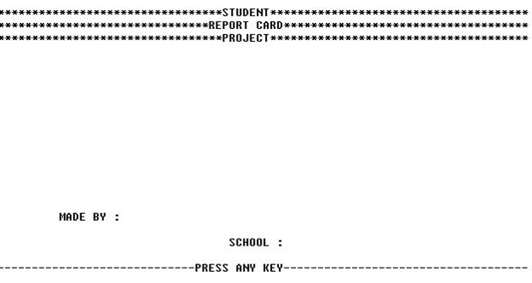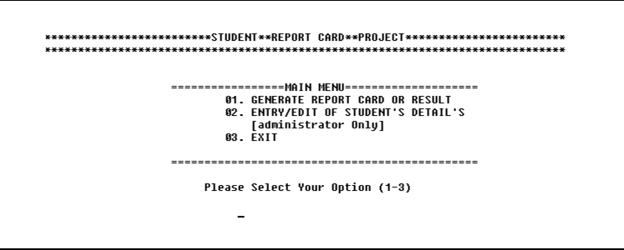

**IF CHOICE IS: 2**

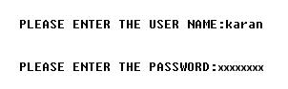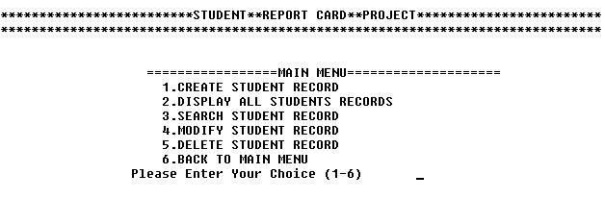

**IF CHOICE : 1**

**IF CHOICE IS 1 OR 2 , 3 ETC.**

**IF CHOICE IS 2: DISPLAY ALL RECORDS**

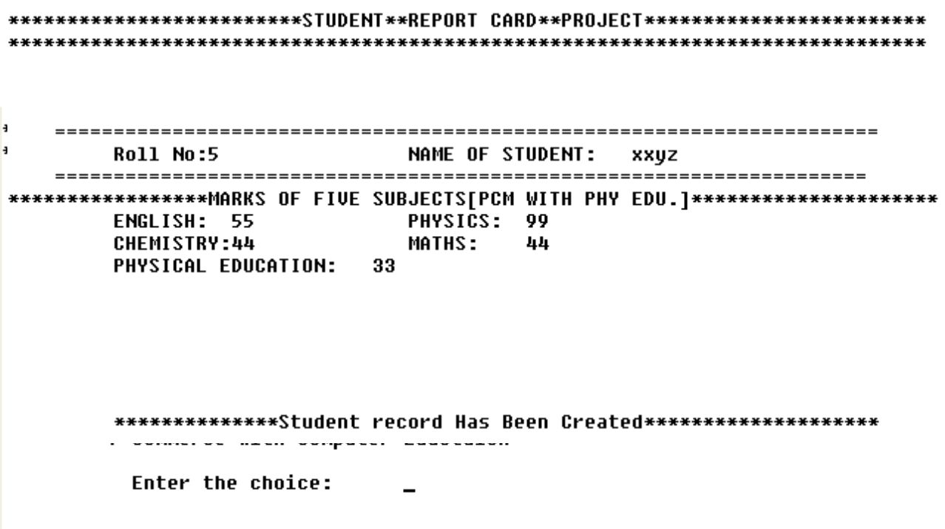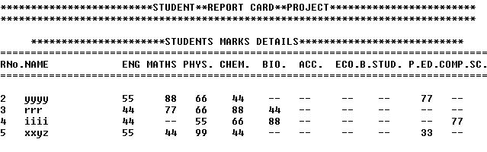

**IF CHOICE : 3 SEARCH AND DISPLAY**

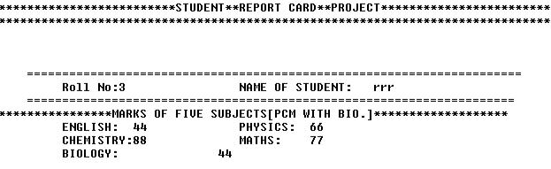

**IF CHOICE : 4 SEARCH AND MODIFY**

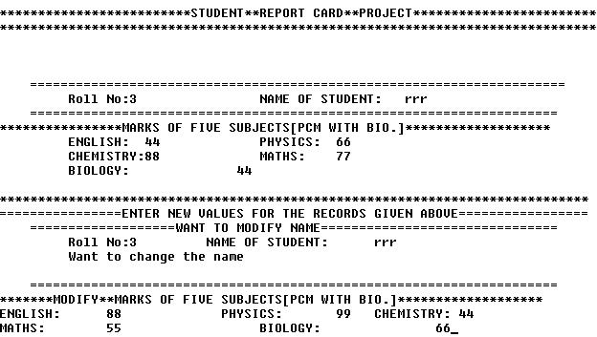

**IF CHOICE : 1 REPORT CARD GENERATE**

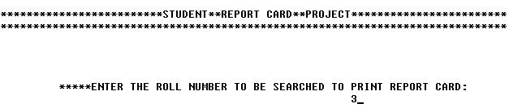

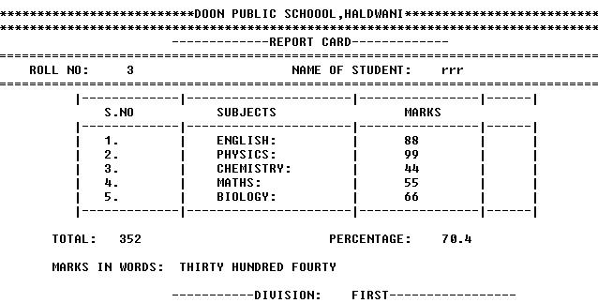

**REQUIREMENTS**

**HARDWARE REQUIRED**

* Printer, to print the required documents of the project
* Compact Drive
* Processor : intel
* Ram : 512 MB or more than 512MB
* Harddisk : 80 GB or more than 80GB.

**SOFTWARE REQUIRED**

* Operating system : Windows XP
* Turbo C++, for execution of program and Ms word, for presentation of output.

**ADVANTAGES**

.

* We can edit the marks of the student easily and generate the report again
* It save the time of the teacher to calculate the percentage and the grade or rank and pass or fail
* This software reduces paper work.
* It is easy to handle student’s record.
* This software saves the time.
* Information of each student stores permanently.

**DISADVANTAGES**

* This system suitable for only small schools.
* Online facility is not available.
* Though we have completed this project with all our effort but has certain limitation like it cannot be operated in networking, the working of project is slow.

**CONCLUSION**

This software is efficient in maintaining student’s details and can easily perform operations on student’s records. This software also reduces the work load of the of teachers in school as all the details are store in computer system and whenever the detail marks of student needed it can be searched and displayed on the screen.

In future, this system can launch on a web portal for easy online entry of students details and marks and student and their parents can login and check the marks and download the reports of their children.

**SYSTEM DESIGN**

**Then we began with the design phase of the system. System design is a solution, a “HOW TO” approach to the creation of a new system. It translates system requirements into ways by which they can be made operational. It is a translational from a user oriented document to a document oriented programmers. For that, it provides the understanding and procedural details necessary for the implementation. Here we use Flowchart to supplement the working of the new system. The system thus made should be reliable, durable and above all should have least possible maintenance costs. It should overcome all the drawbacks of the Old existing system and most important of all meet the user**

**requirements.** START

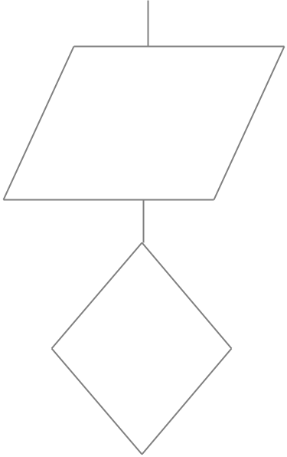

1-report card

2-administrator

3-exit

If choice= 1

If choice=2

If choice =3

then

|  |  |  |  |  |
| --- | --- | --- | --- | --- |
| Report card of the student |  |  | QUIT |  |
| Create the student | |  |
|  | details/SEARCH/EDIT/DELETE | |  |  |

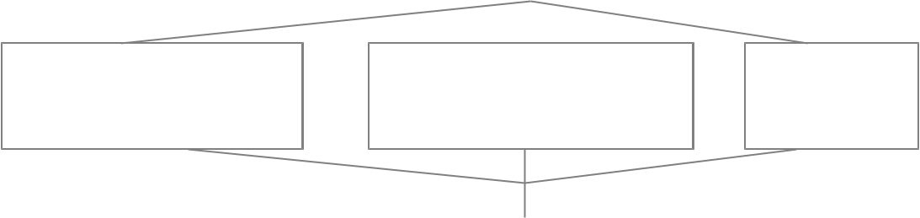

STOP

**REFERENCES**

**Geeksforgeeks**

**Turbo C++**